UCIBuy Purchasing Guidelines/Workflow

Important things to keep in mind:
- All orders must be approved by the PI prior to purchase.
- Purchasing Methods Guide
- UCIBuy Guide

PROCESS (UCIBuy Purchase Order)

- Go to the KFS/Finance page of the ZotPortal, KFS Purchasing tab, and click UCIBuy – Shop Catalog. This will take you into UCIBuy. systems.oit.uci.edu/kfs/b2b.do?methodToCall=shopCatalogs&returnLocation=https://systems.oit.uci.edu/kfs/index.html

- Scroll down to the widgets for the catalogs to order from and click on the vendor you want to purchase from.

- Type in the product you are searching for and click magnifying glass:
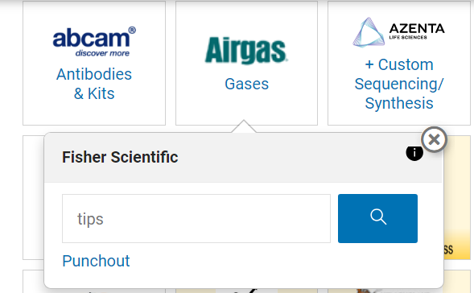

- Chose the item you want from the search results and add to your shopping cart:
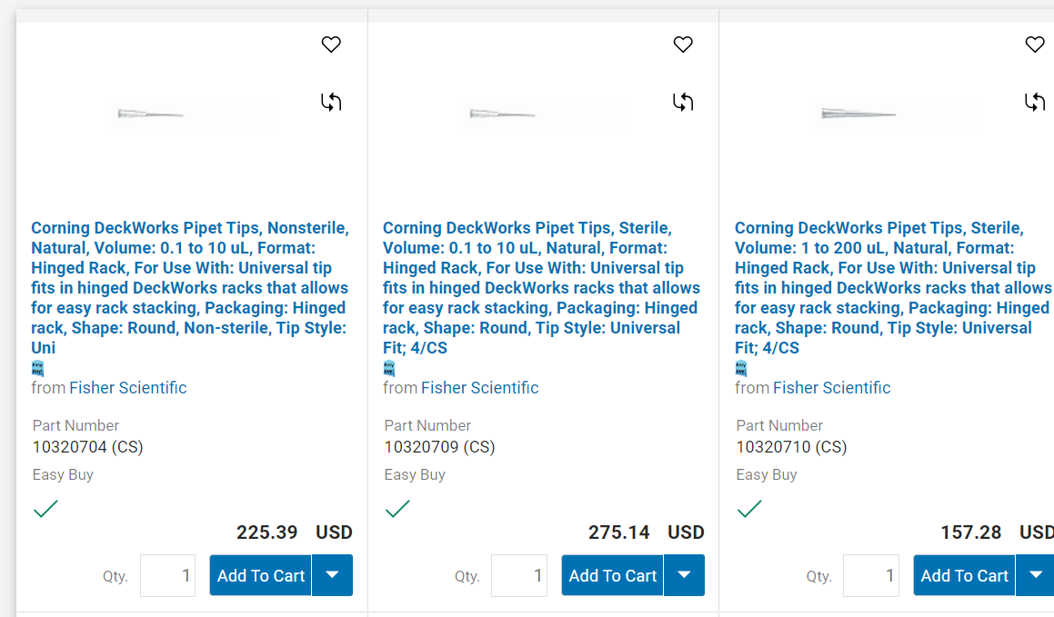

- Repeat this process for all items you are purchasing, then click Checkout:
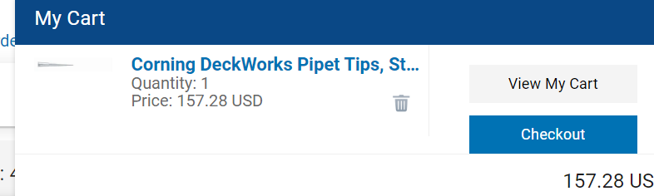
- You will be brought to the requisition page, where you will click Create KFS requisition:

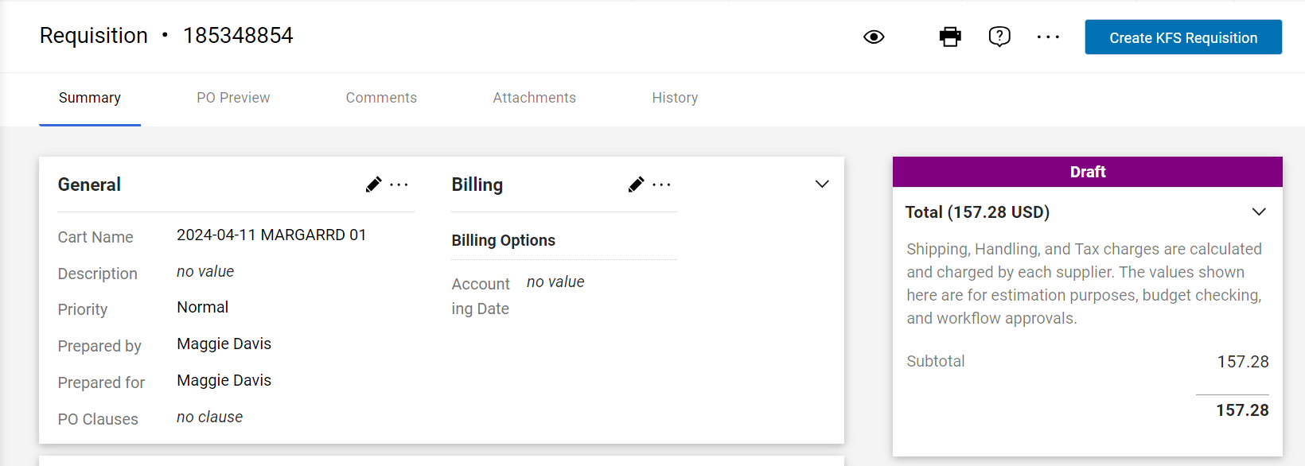

- You will now be brought to your KFS requisition which will have the vendor and items ordered populated in. Save the document and then add your KFS account to the items and save the document, calculate and submit.

- WORKFLOW: Please allow up to two weeks of submission for order to be processed.
  - Lab will initiate UCIBuy Requisition and system automatically routes to NBB Procurement Analyst for review.
  - NBB Procurement Analyst will review and approve UCIBuy Requisition.
  - Procurement will receive UCIBuy Requisition to approve and process for PO number.
  - Purchase Order is created and transmitted to vendor for purchase.
  - Vendor processes order and sends order confirmation to NBB Procurement Analyst.
  - NBB Procurement Analyst forwards order confirmation to requestor.
  - Accounts Payable will receive invoice and process payment.

If you have any questions, please contact NBB Department Procurement Analyst, Maggie Davis (margarrd@uci.edu).

Non-UCIBuy Purchasing Guidelines/Workflow

Important things to keep in mind:
- All Requisitions must be approved by the PI prior to the expense.
- Purchasing Methods Guide
- Requisition Guide
- Purchase Order Guide
- Capital Asset Guide

PROCESS (Non-UCIBuy Purchase Order)
- Request an itemized quote from vendor and ask your PI to approve and confirm the KFS account number that will cover expenses.

- Go to the KFS/Finance page of the ZotPortal, KFS Purchasing tab, and click Requisition. It will open up a blank
requisition. Please complete KFS Requisition and attach itemized quote in Notes section. Financials :: Requisition (uci.edu)

- Document Overview:
  - Description: Enter description of items (ex. Davis – MWI)
  - Explanation: Enter business purpose/justification of items

- Delivery:
  - Building Code: You can search your building number by clicking the magnifying glass. On the Building Code search page type your building name under Building name and hit search. EXAMPLE: *Qureshey* Click on the returned value and it will populate into your document.
  - Address: Shipping Address

BUILDING CODES
McGaugh Hall | 9084
Biological Sciences III | 9079
Qureshey | 9080
Bonney | 9081
Gross Hall | 9342

- Vendor:
  - Suggested Vendor: Click magnifying glass. That opens up the Vendor lookup. Under Vendor Name type the Vendor’s name and click enter – (EXAMPLE: *MWI* - Results will appear, click Return Value on the vendor you searched and it will populate. Save).

- Items:
  - Add items to purchase. When adding your items, you will be required to enter the Commodity Code. To get your code, click the magnifying glass next to Commodity Code. To search, enter what you are purchasing in the Commodity Description box. EXAMPLE: *antibodies* Click on the returned value that works best to describe what you are purchasing. If you know your commodity code, no need to search, just enter it.
  - Once you have the line item filled in, hit the green plus sign and it will add the item to the document.

- Once you have added your line items, click the Setup Distribution button. This will give you a blank line
to enter your KFS account and your object code. To search the object code, click the magnifying glass. Type what you are purchasing and hit search. EXAMPLE: *lab supplies* Click return value on response to your search that fits best.

ITEM | COMMODITY CODE | OBJECT CODE
Antibodies | 12352203 | 8027
Biochemicals | 12352200 | 8027
Computer Equipment and Accessories | 43210000 | see below
Controlled substance | 51211900 | 8027
Gases | 12140000 | 8100
Desktop Computer | 43211507 | see below
Shredding | 80161508 | 7266
Lab supplies | 41121800 | 8090
Lab Equip Maintenance | 81101706 | 7100
Lab Equip | 41100000 | see below
Lab Equip - non inventory | 41100000 | 8085
Office Supplies | 44120000 | 8150
Toner | 44103103 | 8150
Freight | 78121603 | 4200
CAPITAL EQUIPMENT(NOT COMP&FURN) greater than $5,000 |  | 9000
COMPUTER EQUIPMENT greater than $5,000 |  | 9900
COMPUTER EQUIPMENT NON-SOFTWARE less than $5000 |  | 8035

- WORKFLOW: Please allow up to four weeks of submission for order to be processed.
  - Lab or NBB Procurement Analyst will initiate Requisition and system automatically routes to Procurement.
  - Procurement reviews, approves, and issues PO number for purchase.
  - Purchase Order is created and transmitted to vendor for purchase.
  - Vendor processes order and sends order confirmation to NBB Procurement Analyst.
  - NBB Procurement Analyst forwards order confirmation to requestor.
  - Accounts Payable will receive invoice and process payment.

If you have any questions, please contact NBB Department Procurement Analyst, Maggie Davis (margarrd@uci.edu).

